# 1.0 Design Class

## 1.1 Package Diagram

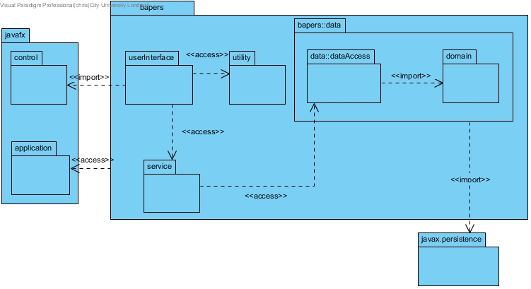

DB connectivity is modelled with the expectation of using the eclipselink library, which is an implementation of JPA, hence the import to javax.persistence. I have simplified the diagram by not showing the persistence unit, as this will be autogenerated by the chosen IDE, making it redundant to show it in the class diagram.

The persistence unit will need to include the following property: <property name="javax.persistence.jdbc.url" value="jdbc:mysql://localhost:3306/bapers?zeroDateTimeBehavior=convertToNull&amp;autoReconnect=true&amp;useSSL=true"/>

The userInterface will utilise javaFX; each form will have three separate files, a bapers::fxml::form.fxml, bapers::styles::form.css and bapers::FormController.java. The fxml file details objects within the form, and their respective location, and the controller class will describe the behaviour of the forms objects. However, for the sake of brevity, I have simplified this for the class diagram by bundling all three files into a single boundary class, and making the userInteface package, where they will be stored.

## 1.2 Simplified Design Class Diagram

The following diagram presents the full class diagram; however, all classes have been stripped of their members. This is to concisely show all associations. Full details will be provided in section 1.3.

Please note that the javax.persistence package appears more than once. This was to allow for neater formatting of the diagram, all repeated instances should be treated as part of the same package. This also applies to any other repeated packages/classes.

### 1.2.1

This diagram excludes all entities from the bapers::data::domain package, as the associations for that package will be shown in the detailed diagram in section 1.3.